Runtime Analysis of Linux Drivers (Kernel Modules)

Summary
We develop a system for the analysis of Linux drivers (kernel modules) in runtime. It should allow checking for various kinds of errors in a driver chosen by the user: incorrect resource allocation and deallocation, unhandled failures of the system functions called by the driver, etc. We strive to design and implement this analysis engine so that it would be easy to extend: to add support for checking for new types of errors, new fault simulation scenarios and more.

The ideas behind this driver analysis engine resemble to some extent those implemented in the test kits for Novell YES Certified program and in Driver Verifier for Microsoft Windows.

The basic technologies our system relies upon are currently used heavily in the Linux kernel itself.

The analysis system will probably be useful mostly for driver developers and maintainers. It could be of help for the certification systems for Linux drivers as well.

1. Reliability of Drivers
To check reliability of a driver, one needs to check at least the following.
- Requirements common for all the drivers (usually implicit): a driver must not corrupt or leak memory; if a function that a driver uses can fail, the driver must properly handle this situation, the driver must operate without race conditions and deadlocks, etc.
- Requirements common for several classes of drivers, for example, common requirements can be imposed on the drivers for Plug-and-Play devices. There could be other requirements concerning proper handling of system startup, shutdown, hibernate, wake up, etc.
- Requirements specific to a particular class of drivers (and the corresponding devices): audio, networking, video drivers, etc.

The requirements of the 2nd and the 3rd kind are usually checked by appropriate test suites. For example, one can consider the tests for drivers on Microsoft Windows from the Windows Logo Kit (WLK) as well as the test kits for Linux drivers from Novell YES Certified program.

The requirements of the 1st kind (those common for all the drivers) could also be checked in runtime, given appropriate tools. It is usually beneficial to check them using the same or similar test kits as for the requirements of the 2nd and the 3rd kind. While the tests force the target driver to do something, the special tools check if the driver corrupts memory, has a potential for a deadlock, does not properly handle a refusal of the system to allocate memory or register a device object, etc.

Some of the tools from Microsoft WLK and Novell YES Certified program seem to do that, more on this below (see "Existing Systems for Runtime Analysis of Drivers").

To provide the means to check the common requirements is also one of the goals of the system for runtime analysis of Linux kernel modules that we develop.

2. Common Errors in Linux Drivers
According to the data from kernel.org (change logs, bug tracker) for the recent stable releases of the Linux kernel (2.6.33.*), unhandled error conditions, bad pointer operations, buffer overflows and memory leaks, race conditions and deadlocks are still a problem in the kernel modules. The tools that could allow the driver developers to reveal these and other kinds of errors during the development process would help improve the reliability of the drivers and the Linux kernel as a whole.

Actually, there are tools in the kernel itself that address some of the problems listed above: kmemcheck, kmemleak, fault injection framework, various debugging facilities, etc. Still, these tools mostly operate on the kernel as a whole rather than on the particular driver (kernel module) chosen by the user. Having a complementary runtime analysis system that operates on the target kernel module only and does not significantly affect the rest of the kernel would be beneficial.

If such system was available and was extensible enough, different tools to check for the errors described above could be developed on top of it. For example, a fault simulation tool could help reveal the problems in "error paths": unhandled memory allocation failures, object initialization failures, etc. A memory operation checker (perhaps similar to the special pool tracking facilities in Driver Verifier for Windows) could be used to discover buffer overflows and use-after-free errors, etc. Other tools built on top of the analysis system could check other aspects of the module's functionality.

3. Existing Systems for Runtime Analysis of Drivers
There are at least two systems that can reveal some of the common errors in a chosen driver: Driver Verifier on Microsoft Windows and "impostor" facilities from the test kits for Novell YES Certified program on Linux.

3.1. Microsoft Driver Verifier
Driver Verifier is probably one of the crucial tools not only for checking drivers during a certification process but also for revealing the errors in a driver during its development. It is very important for driver developers too, so it is no surprise that Microsoft recommends using it in the testing stages of the development.

Driver Verifier does the following:
- it monitors the execution of a target driver and checks correctness of memory allocation/deallocation, DMA, operations with handles, and a lot of other operations;
- it can simulate situations where the system is short of resources (makes calls to the appropriate system functions fail) to check if the target drivers handles this correctly;
- it provides a set of counters that can be helpful to analyze the behavior of the target driver: number of attempts for memory allocation and number of successful allocations, number of times the driver acquired a spinlock and several more.

Driver Verifier has been continually enhanced to check for more and more types of errors since at least the late 1990s and up to the present time. Starting from Microsoft Windows 2000, it is distributed as a part of the operating system.

Unfortunately, there seem to be no tools on Linux as powerful as Driver Verifier. However, the ideas implemented in the test kits for Novell YES Certified program look very promising.

3.2. Novell YES Tools: "Impostor" and "Call Swapping" Facilities
Some of the test kits for Novell YES Certified program use "call swapping" technique to check memory operations and perform fault simulation. The idea is to change the symbol table of the driver before it is loaded so that the names of the system functions of interest ("target functions") used by the driver are changed to the names of the so called "impostor" functions (__kmalloc changes to something like __Kmalloc, etc.). The impostor functions have the same signatures as the respective target functions and are implemented in a separate kernel module.

The symbol table is changed for the driver file itself rather than for its image loaded in memory. This is done in user space which probably allows to simplify the development and debugging of the call swapping mechanism.

When the target driver (kernel module) is loaded and tries to call some target function, a corresponding "impostor" function will be called instead. This function may arrange for memory allocation to be performed from a special ("checked") memory pool or it may simulate failure of the target function (without actually calling the latter), etc.

Unfortunately, this functionality is not available in a standalone tool and the driver analysis system is not quite flexible and extensible. For example, the scenarios defining which calls to fail during the fault simulation seem to be hard-coded there with no opportunity for a test developer to provide a new scenario. Besides that, it is not easy to add a new set of "impostor" functions there that implement some other kind of analysis or new types of tests.

4. Our System
The ideas behind the system for analysis of drivers in runtime that we develop are to some extent similar to those implemented in the systems described above.

Our system also relies on the replacement of the calls to the system functions in the target kernel module. Unlike call swapping performed by the Novell YES Tools, the replacement is performed in the memory image of the target module after it has been loaded (but before its initialization function is executed).

The calls to the functions of interest are replaced with calls to the corresponding "replacement" functions that actually collect the necessary data about the arguments and the result of each target function called, output this data to the user space, etc. On the other hand, the "replacement" functions can simulate failure of a target function to check if the driver handles such situation correctly.

The system currently allows to analyze one driver at a time. In the future, adding support for the analysis of a group of drivers at the same time may be considered if there is a need for this.

4.1. Central Principles
Here are the central principles we have chosen to base our runtime analysis system on.
- Minimal influence on the rest of the kernel. The analysis of a target driver should affect the rest of the kernel as little as possible.
- Extensibility. The system should allow the developers to prepare custom analysis/testing tools for the corresponding drivers on top of it if they want to. The system should provide a convenient platform for the development of such tools.
- Ease of use from user-space applications. Test suites for drivers are an example of such application.

4.2. General Use Case
Described here is the general use case for the runtime analysis of a driver (kernel module) for Linux with the system we develop.
The steps listed below can be performed manually or more likely by a user-space application.
- At the beginning, the target module is not loaded.
- The user loads the core of the analysis system and passes it the name the target module. The analysis system begins watching for the target module to load.
- The user decides which operation (s)he would like to perform on the target module: record which calls to the system functions the module makes, perform fault simulation for a particular groups of functions or check some other rules, etc. The user loads appropriate kernel modules that implement these operations ("payload modules").
- The user loads the target module (or plugs in a device that as the system knows, should be handled by the target module or does something else that results in loading of the target module). When the target module is loaded but before it begins to perform its initialization, the analysis system detects that and hooks into it (instruments it) for the payload modules to be able to work.
- The user performs actions on the target module: reads data from the corresponding device file and/or writes data to it, performs ioctl() calls or any other operation (s)he wants to. As this is being done, the analysis system does its work too: collects the necessary data about the operation of the target module, performs fault simulation, etc.
- If necessary, after each action, the user may check the trace output by the payload modules to determine if the target module operates correctly. For example, it could be checked if there are calls to sleep(), schedule(), __kmalloc with GFP_KERNEL flag or the like in an atomic context (where such calls are not allowed). On the other hand, the analysis of the trace could be postponed if necessary, until the target module is unloaded.
- The user unloads the target module (or does something else that results in unloading of the module: unplugs the corresponding device, etc.).
- The user (actually, a user-space application chosen by the user) analyzes the trace and/or any other results output by the analysis system and decides whether the target module behaved as it was required.
- If it is necessary to analyze the target module once more (may be, perform a different types of checks), the user repeats the process from step 2. The payload modules that are no longer needed could be unloaded, the necessary payload modules could be loaded. If the analysis is done, the user unloads all the components of the analysis system or just reboots the OS.

As a variation of this use case, it could be possible to analyze an already loaded and initialized target module. In this case, the analysis system finds the target by the name specified by the user and instruments the target module. Before unloading, the analysis system checks if the target module is still loaded and if so, "unhooks" itself from it (restores original call addresses in the target module).

4.3. Fault Simulation
For the present time, the fault injection framework included in the kernel, also seems to operate on the kernel as a whole and to inject faults in a random way. A "targeted" fault simulation system that operates on a particular kernel module and applies a scenario chosen by the user would be a valuable complement to the in-kernel fault injection facilities.

Currently, we are working on such fault simulation mechanism in our analysis system as well. Similar to Driver Verifier, the tool should be able to simulate low memory conditions in a Linux system. This, however, is only one of our goals. We are working to provide support for different fault simulation scenarios that can be built-in or specified by the user. It should be possible to specify fault simulation scenarios separately for each target function. The scenarios available for a given function, say, __kmalloc(size, flags), will probably include (but may be not limited to) the following ones:
- fail each call;
- fail each call after the initialization of the target module completes;
- fail only calls with 'size' greater than N and 'flags' == GFP_ATOMIC
- fail the call if the amount of memory already allocated with __kmalloc is greater than N
- ...

4.4. System Architecture
The figure below presents an outline of the architecture of our analysis system. The green blocks are the main logical parts of the system.

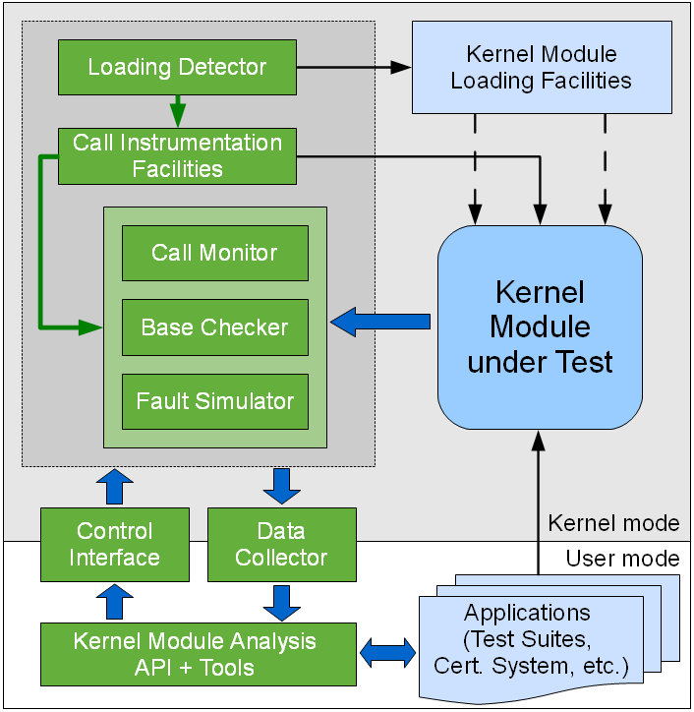
The main logical parts of the system are as follows:
- Loading Detector watches for the target module to load and calls the instrumentation facilities at the appropriate time (after the target is loaded but before it begins to execute its initialization function).
- Call Instrumentation Facilities use the data provided by the "payload" components and replace the calls to the system functions of interest (target functions) in the loaded target module with the calls to the corresponding functions from the payload modules
- "Payload" components actually implement the logic of data collection, analysis, fault simulation, and so on (Call Monitor, Base Checker, Fault Simulator, ...). These components can be "plugged in" into the analysis system as needed. A developer may prepare custom payload components and use them with our system.
- Control Interface allows to influence the analysis from the user-space applications, for example, to load fault simulation scenarios provided by the user (a scenario specifies which functions to fail and in what conditions).
- Data Collector allows the user-space applications to retrieve data about the behavior of the target module that have been collected in the kernel space by the payload modules. The data may be a call trace, for example, i.e. the information about which functions the target module called, when, with what arguments and with what result. The data can then be analyzed by the user-space applications (including tests) to determine if the target behaves correctly.
- Kernel Module Analysis API and Tools provide a convenience interface for the user-space applications to control the analysis and obtain the collected data.

4.5. Supported Platforms
The system is intended to support kernel versions 2.6.31 or newer. Of all kernel facilities it relies upon, trace events currently have the highest requirements for the version of the kernel.

For now, only x86 and x86_64 architectures are supported. We may consider adding support for other architectures later on.

4.6. Standing on the Shoulders
The core components of our analysis system are being developed based on the technologies heavily used in the kernel itself, for example:
- instruction decoding facilities used in the kernel to implement KProbes;
- trace points and trace events - the basis of various data collection systems used in the kernel;
- netlink as the mechanism for data exchange between the kernel space and the user space (we consider using it to implement a control interface for the analysis system).

4.7. Integration with Other Tools
There are possibilities for our runtime analysis system to be able to integrate with the widely used kernel analysis tools like SystemTap, LTTng, etc. For example, our system is going to rely on trace events and trace points to collect the requested data and transfer it to the appropriate trace file. As SystemTap and LTTng can handle trace points and are able to get data from them, this gives the opportunity to use these tools in conjunction with our system. The handlers for the corresponding trace events could probably be used in SystemTap scenarios, the trace could be processed with LTTng tools, etc. Nevertheless, our system will be able to operate standalone as well.

